B. In-Depth Explanation & Analysis
1. Ocean Floor Configuration
- Continental Shelf: The shallow, gently sloping edge of a continent that's underwater. This is where most fish are caught and oil is drilled.
- Continental Slope: The steep drop-off from the shelf down to the deep ocean floor.
- Deep Sea Plain (Abyssal Plain): The incredibly flat, deep floor of the ocean.
- Ocean Deeps (Trenches): The deepest parts, formed at convergent plate boundaries (subduction zones). E.g., Mariana Trench.
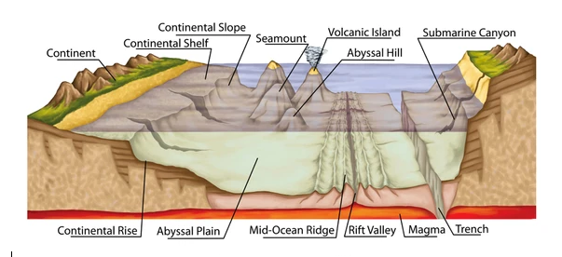
Relief features of ocean floor
2. Salinity: Why isn't the Equator the saltiest? You'd think maximum heat = maximum evaporation = maximum salt. But the Equator also gets massive rainfall daily, which dilutes the salt.
- Real highest salinity: Subtropical High-pressure belts (around 20°-30° N/S), where it's hot and dry with high evaporation and little rain.
3. Tides: Spring vs. Neap
- Spring Tides: Happen at Full Moon and New Moon. The Earth, Moon, and Sun are in a straight line (syzygy). Their gravities add up, causing extra high high tides and extra low low tides. (Think: "Springing up").
- Neap Tides: Happen at Quarter Moons. The Sun and Moon are at right angles (90°) to Earth. Their gravities partially cancel each other out, causing lower high tides and higher low tides (less difference).
4. Ocean Currents and Climate Currents are Earth's heating/cooling system.
- Example: The Gulf Stream (warm) carries tropical heat up to Northwest Europe, keeping ports in Norway ice-free in winter, while similar latitudes in Canada are frozen solid.
- Example: Cold currents (like the Peru Current) cool adjacent coasts, often creating coastal deserts (like the Atacama) because cool air doesn't hold much moisture for rain.
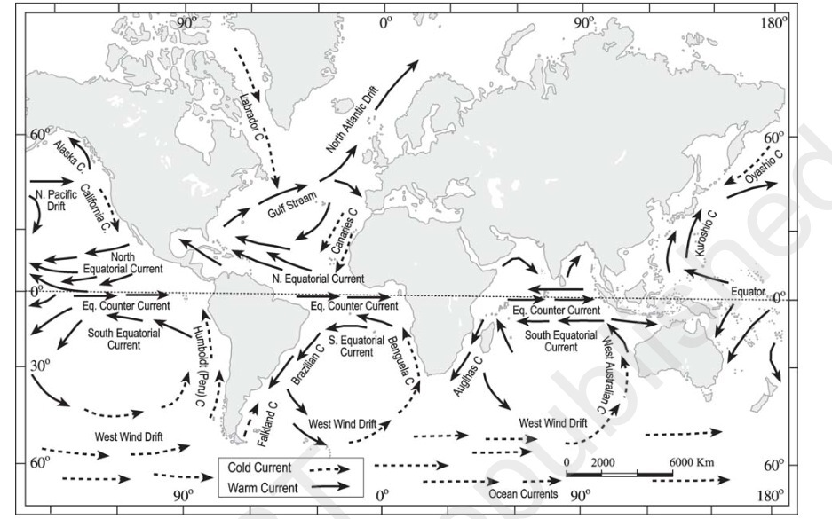
Major currents in The Pacific, Atlantic and Indian ocean

Mentor’s insight:
- Ocean temperature decreases polewards (average surface 27°C equator to 0°C poles) due to latitude, land-water distribution, winds and currents. Vertical profile shows thermocline (100-400m, rapid drop), three layers warm surface (20-25°C, 500m), thermocline (500-1000m drop), cold deep (>90% volume near 0°C).
- Salinity is calculated as the amount of salt (in gm) dissolved in 1,000gm seawater. It is usually expressed as part per thousand (‰) or ppt. Salinity on surface layer is mainly affected by evaporation and precipitation, wind, currents and varies region to region. Salinity, temperature and density are interrelated, influencing each other.
- If a long question is asked on the relief of the ocean floor, make sure to draw the diagram of the relief of the ocean floor. In geography diagrams are necessary to secure full marks.
- Types of tides: Tides based on frequency (semi-diurnal tide, diurnal tide and mixed tide), Tides based on the Sun, Moon, and the Earth position (spring tides and neap tides).
- The time between the low tide and high tide, when the water level is falling is called the ebb.

